**Test Case 7 – Folded roof element**

*Test Description* : A simple two-zone model (an occupied zone and an attic zone) forms the basis of a proposed series of tests of roof geometry. Roofs are regions often experimented with, that may have several complex folds that could not come in cleanly in gbXML. This test is very simple, a one zone model with a steeply sloped gable embedded in a roof that slopes in multiple directions.

*Space Names:* This is important because the gbXML validator requires the strings in the test file match the standard file. The name check is case sensitive. Ensure that the id attribute of the Space elements in the gbXML test file match the standard file space names shown below.

|  |  |  |
| --- | --- | --- |
| Standard File Space Name | Test File Space Name | Verified |
| sp-1-Space |  |  |
| sp-2-Space |  |  |
|  |  |  |

*Special Considerations:*

*Complexity of the BIM Model:*

1. Simple planar surfaces orthogonal to the project Cartesian reference frame.
2. Simplified walls with no visible layers.
3. Simple details at interfaces of surfaces.
4. Egg shell models can be tested in this example.

*Description of Test:*

Figure 1 shows a simple 3D axonometric view of how the example is massed. It is a simple space, with all complexity in the roof element. Also note that the wall required to enclose the volume created by the gable is triangular, and modeled as a separate surface than the wall below it for Sp-2. Figure 2 shows the dimensions of the gable in more detail, which should be sufficient to draw the gable. The roof thickness is also shown.

Figure 3 goes on to show the dimensions of the slab and wall thicknesses. Figure 4 shows the floor plan of the first floor, revealing the simple geometric dimensions, centerline to centerline. Figure 5, finally, may offer some final hints on how to model the gable and roof that bounds Sp-2.

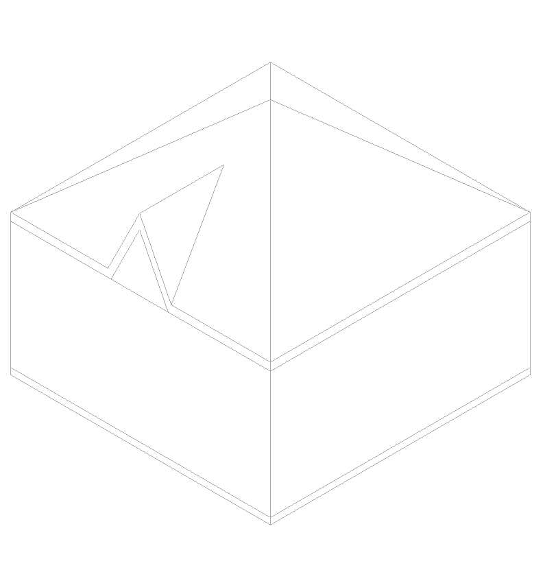

N

Figure 1: Test case 7 shown in an axonometric view to reveal the simple steep gable in the roof.

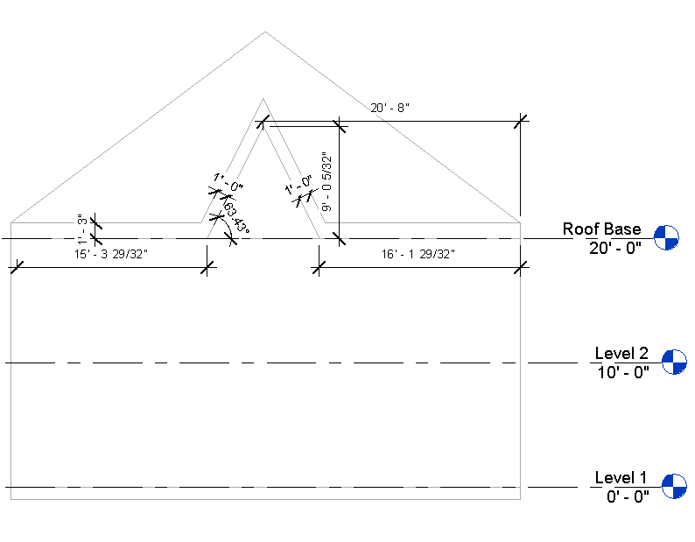

Figure 2: South elevation, detailing the geometry of the small gable

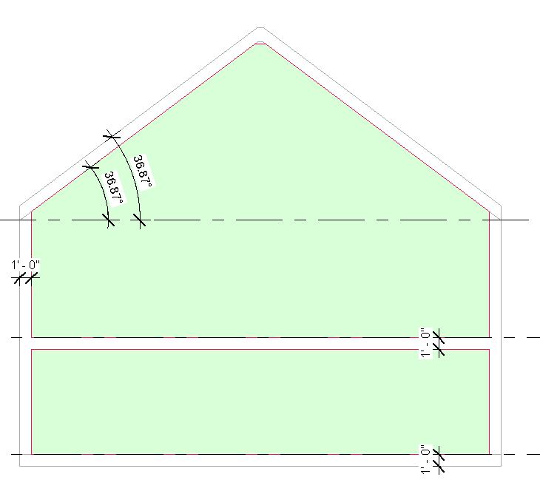

Figure 3: Section looking south, with details of wall thickness and the slope of the roof.

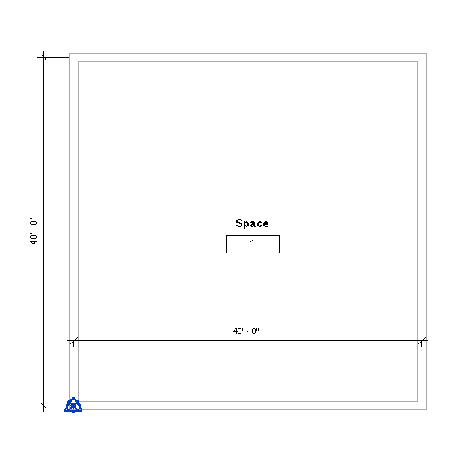

Figure 4: The first floor floor plan. Dimensions of the floor plate are shown, centerline to centerline.

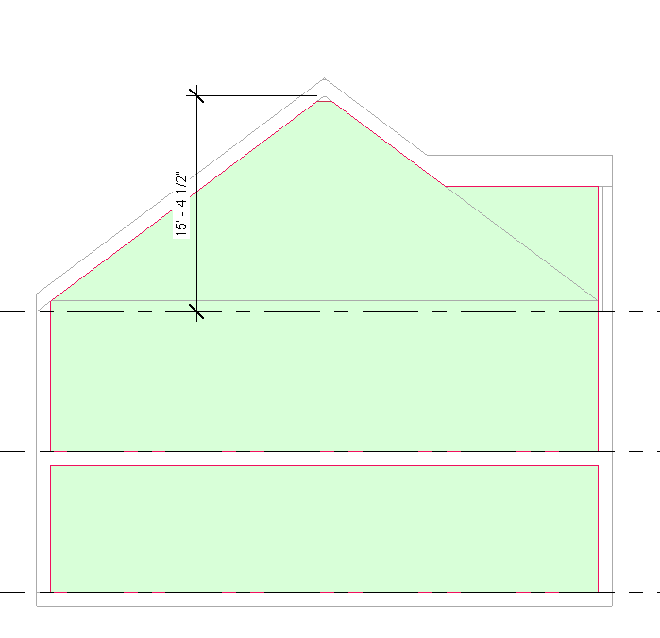

Figure 5: Section looking east. This may be helpful in finding the area of the walls in Sp-2 in particular.

|  |  |  |  |
| --- | --- | --- | --- |
| Surface Description | Surface Thickness | Surface Type | Comments |
| Exterior Wall | 12” | n/a |  |
| Roof | 12” | n/a |  |
| Interior Floor Slab | 12” | n/a |  |

Table 1: Dimensions and descriptions of wall elements in Test Case 8.

*Example of the gbXML Code Relevant to this Example*

This test case will have no very unique cases that will require deep explanation, and all information about this test case can be found in the gbXML Implementation Guide.